Design Document

By Kenneth Mallabo & Zinah al Bagdadi

# Usability Heuristics

## Visibility of system status

This heuristic is about informing users on what is going on. This is adhered to by the use of the tab bar which notifies users where they are in the website. This can be seen on figure 1.

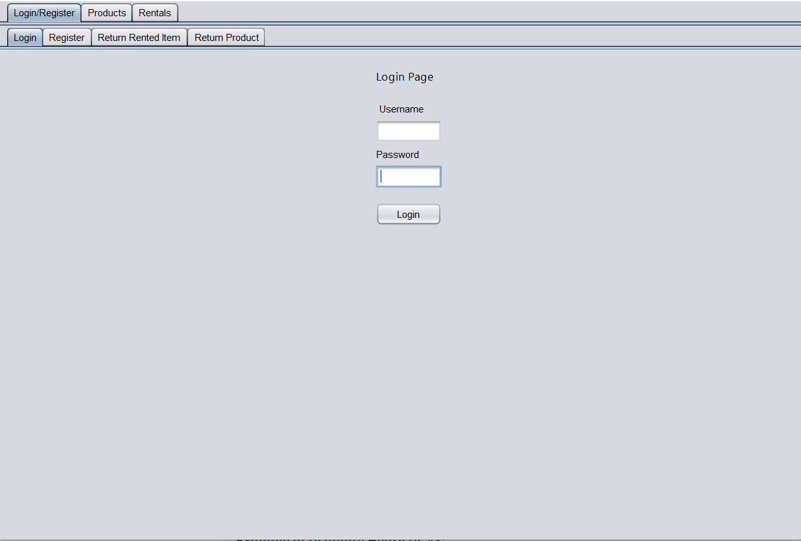

Figure : Login/Register page

## User control and freedom

User should be given the functionality to redo or cancel their actions. The logout page exists to allow the user to exit their account.

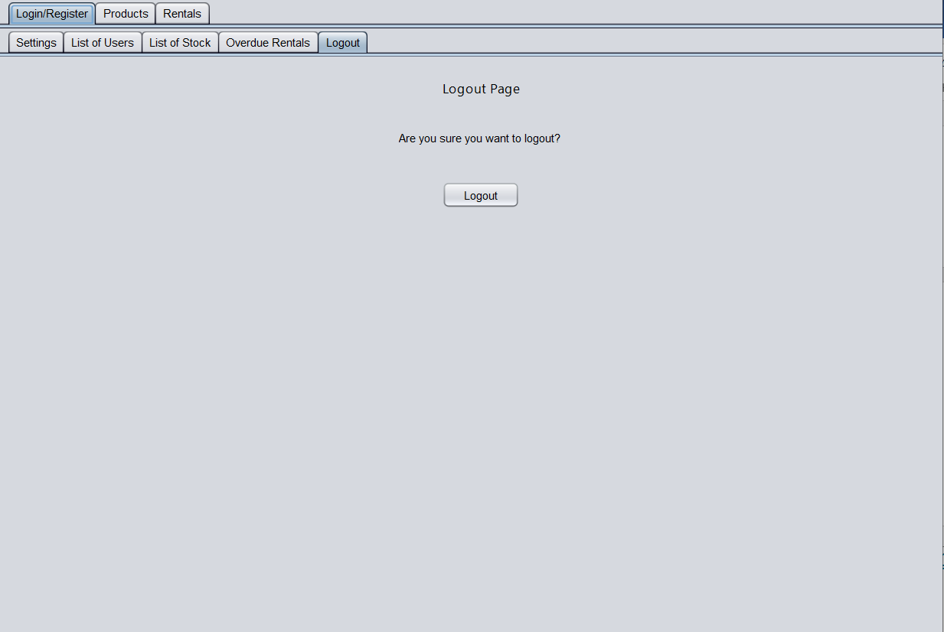

Figure : Logout page

## Recognition rather than recall

This is a heuristic that emphasises using recognition rather than recall. Recall means trying to remember information like “What is the capital of Ireland?”. In contrast, recognition means trying to remember information like “Is Dublin the capital of Ireland”. Recognition requires less effort on the user’s part. Apart from the already mentioned tab bars, in figure 4 there is a table with fields to signify the type of information in each column expected.

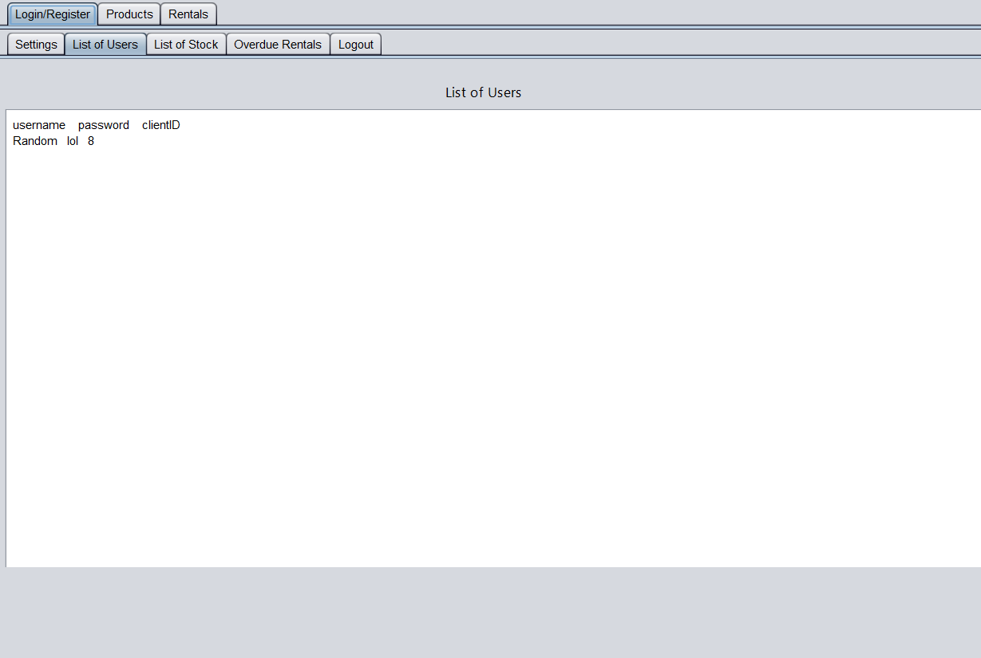

Figure : Admin's List of Users page

## Error Prevention

Preventing a mistake from happening in the first place before committing to it is more important than error message after the action. This is implemented in some subtabs like the “Return Product” which upon pressing the button, a popup appears with a yes or no option telling the user if they wish to continue with this action.

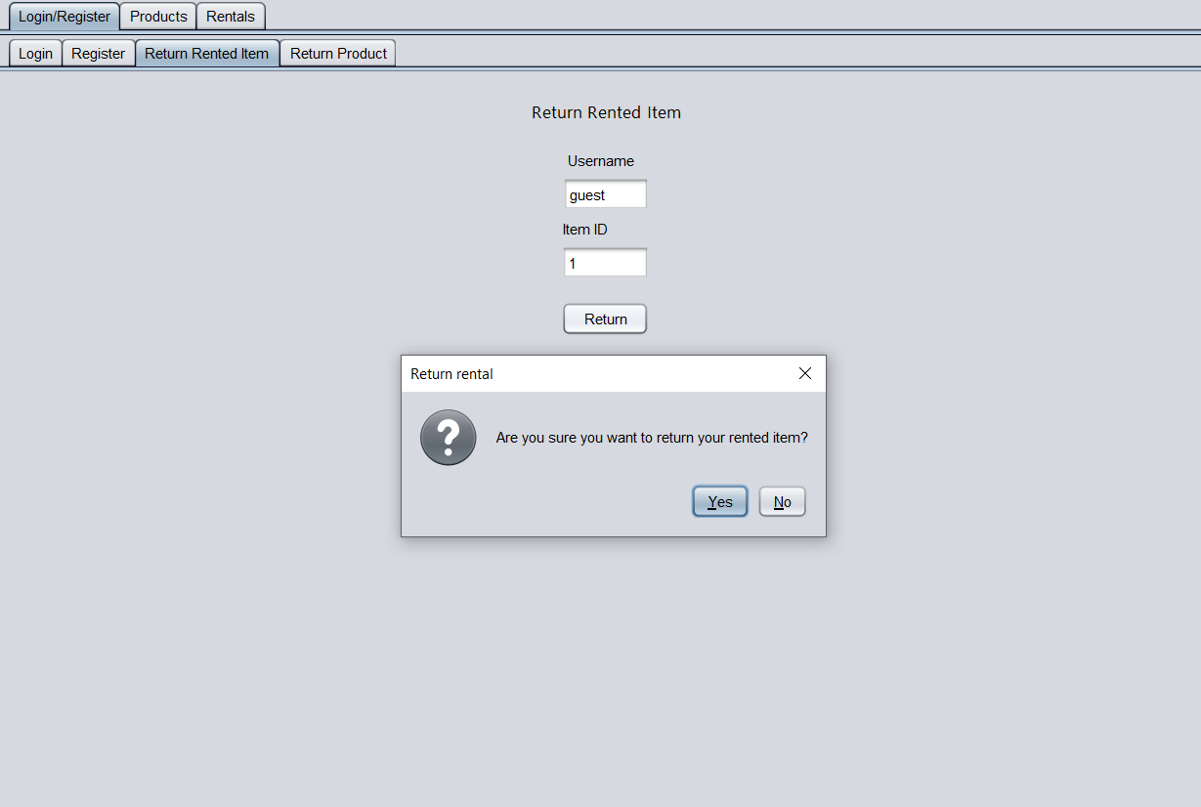

Figure : Popup confirmation

## Help users recognise, diagnose, and recover from errors

Error messages should be simple, concise and provide solutions. An example from the application is that in the login page, if the username is left empty a popup message informs the user to enter a username.

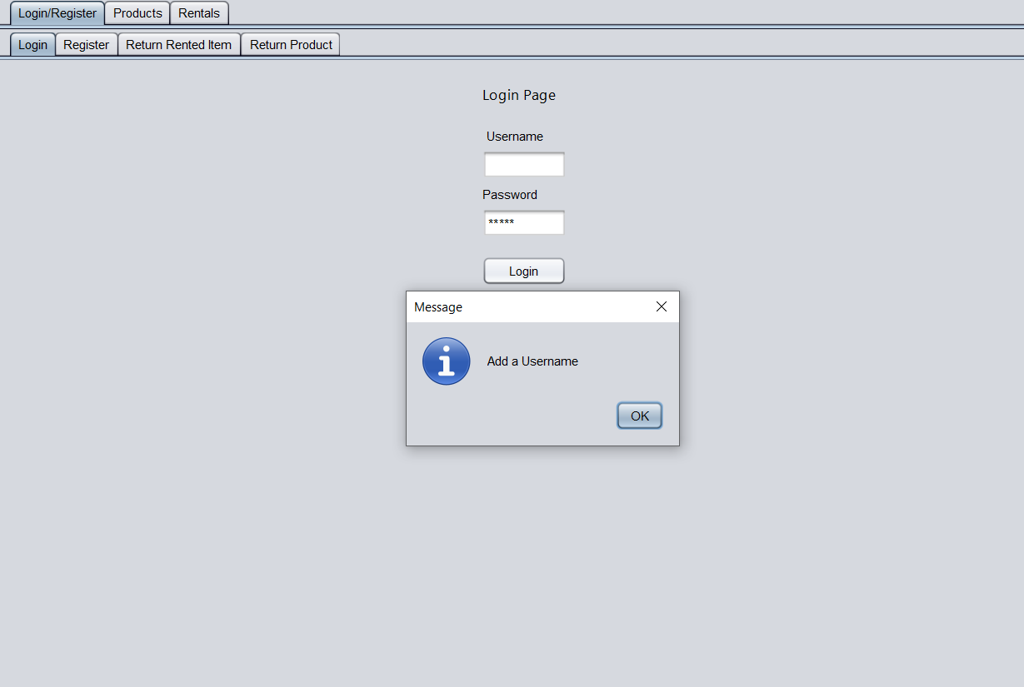

Figure : Error message popup

# References

Nielsen Norman Group. (2020). *10 Usability Heuristics for User Interface Design* [online]. Available from: <https://www.nngroup.com/articles/ten-usability-heuristics/> [accessed 23 November 2022].